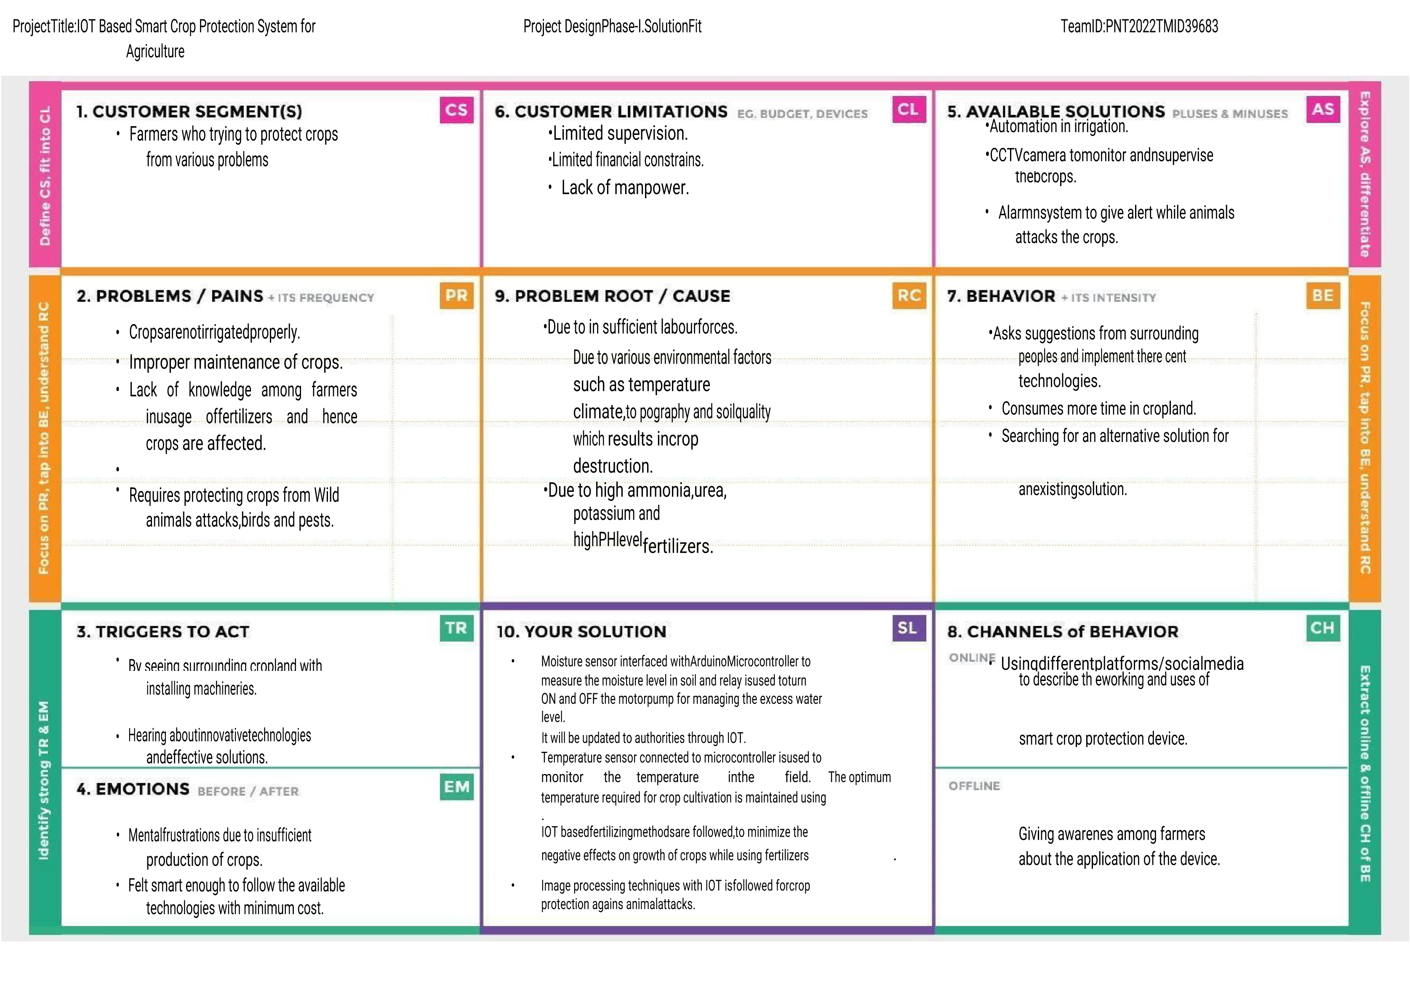

Team ID-PNT2022TMID24757